**Flynn’s Website**

I Used Notepad++ / Drive to Make a Moon Board /google Fonts / GitHub and Logos. This Is How I Made My Website

**Design Brief**

Flynn&#39;s Arcade has been slowly losing money as the trend for accessing video games has moved away from social

&#39;video game arcades&#39; to at home &#39;video game consoles&#39; such as the Atari &amp; Commadore 64. Flynn wants to

reposition his business as a venue for selling new games and trading used games. Flynn wants you to design and

create ‘alpha phase’ website that communicates his new business model. (More information on Flynn’s Arcade:

***Website***

Tron: Legacy - Wikipedia

TRON | Tron Wiki | FANDOM powered by Wikia

***I did not get to Find Lots of The Website I Went On***

***Cms***

A content management system CMS is a software application or set of related programs that are used to create and manage digital content. CM tes are typically used for enterprise content management ECM and web content management WCM

***Ide***

A java ide for Integrated Development Environment is a software application which enables users to more easily write and debug Java programs. Many Ides provide features like syntax highlighting and code completion, which help the user to code more easily.

***Drag and******Drop***

Drag and drop Is a Very Easy Feature to Use Because You Grab an Item and You Move It to a Different Location. It Good For people because It Help People To Move Stuff and People Move Stuff Easier

***This Is my Website and How It Looks***

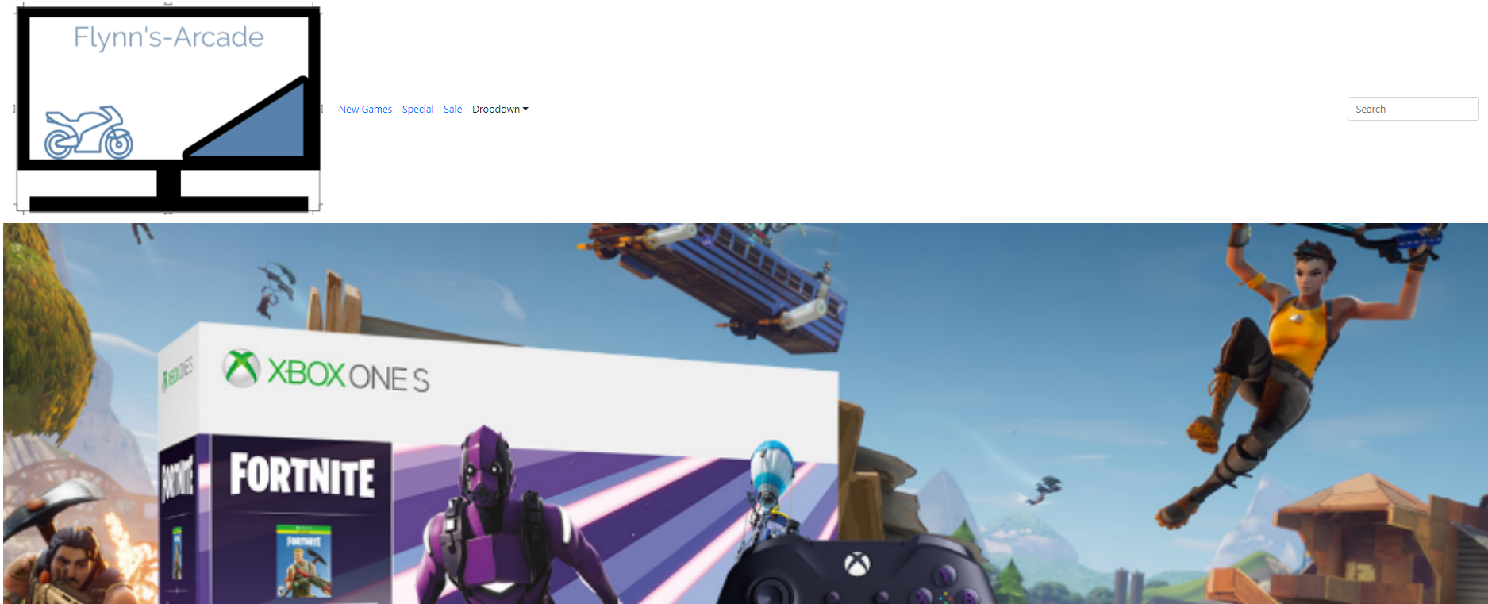

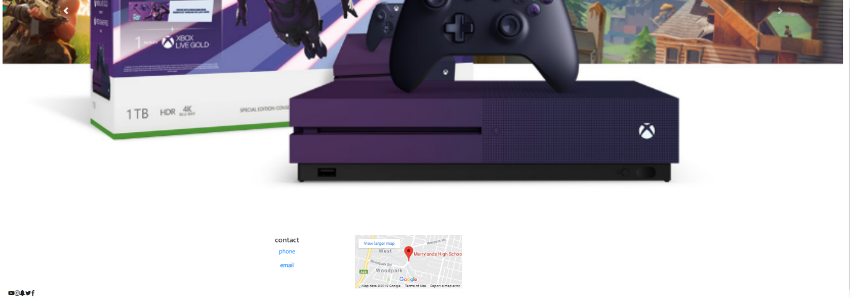

***Moon Board***

Here Is My Moon Board. The Stuff I Used It Was Because Enjoy Looking At It and It Looks Clean and My Font Is On Top Corner. The Colours I Got From a Website with This Photo

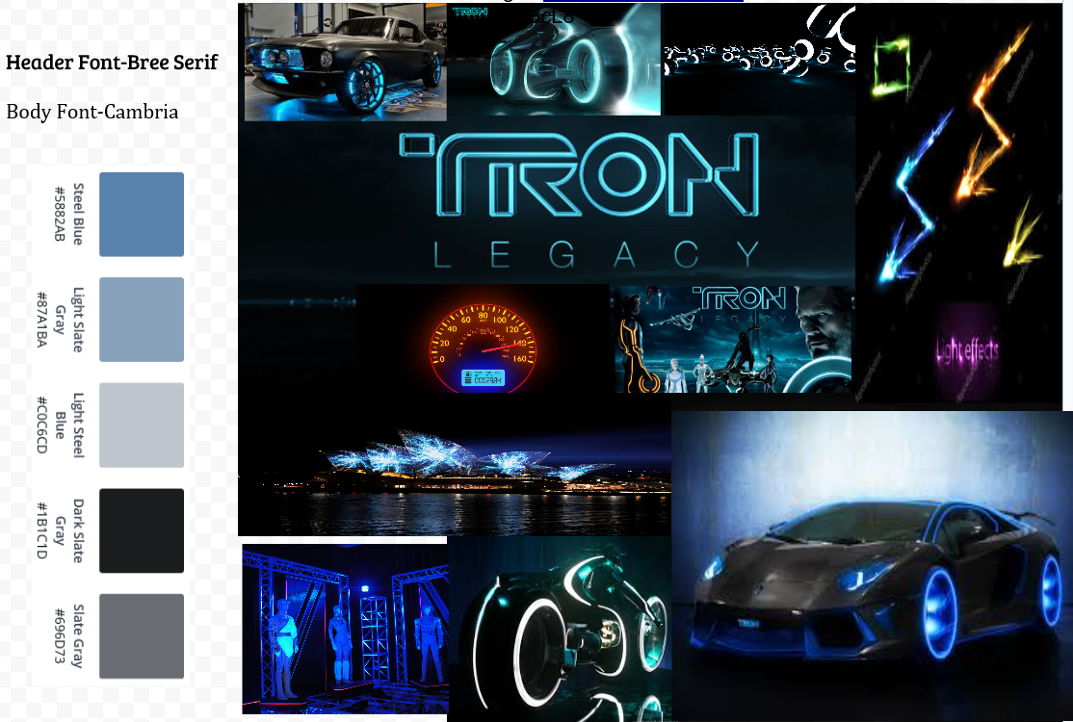

I Made the Moon Because In Tron Every Thing Is Almost All Neo the People and Their Clothes and Their Bikes and Way More Things

My Sketch Are In the Next Page ++

***Logo***

Now I Will Show You My Logo Is like Tron Legacy I Put Stuff with Neo like the Cars like the Opera house And I Put the Name of the Movie So It Tells You What It Is About

You think you’re playing the Game without Getting in The Game so That Makes People Want to Buy It. If I Where See My Logo Being Used I Will Question Them I Am Proud of What I Did But I need It To look Better

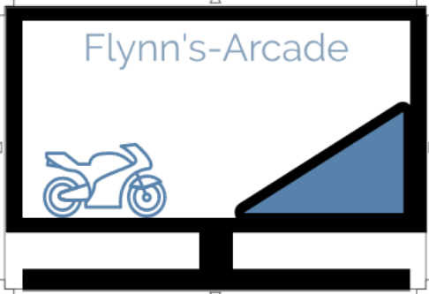

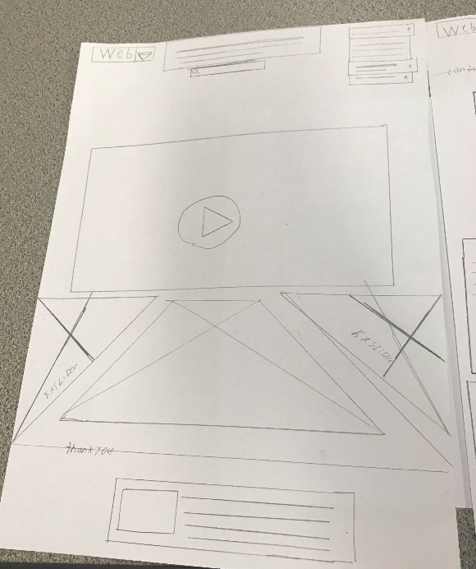

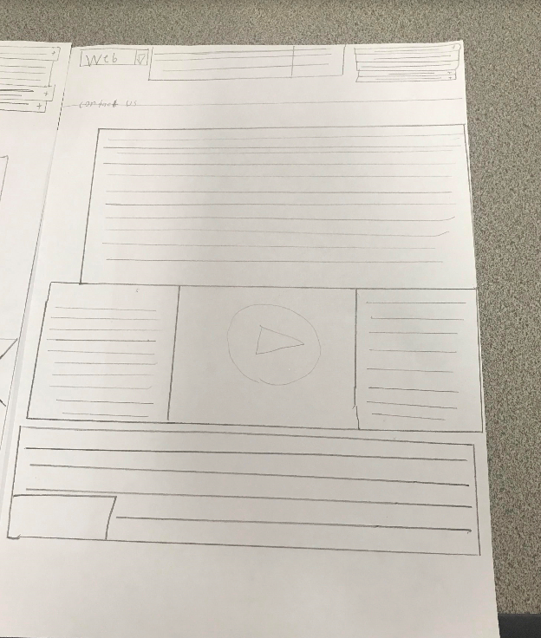

I Made This Sketch’s The Way I Thought My Website Was Going To Look Like but I made a Way Different Website Where It Looks Good But I Wanted It To Come Out The Way I Draw It But It Good And I Am Proud The Way It Come Out ☺

***Logo on Phone***

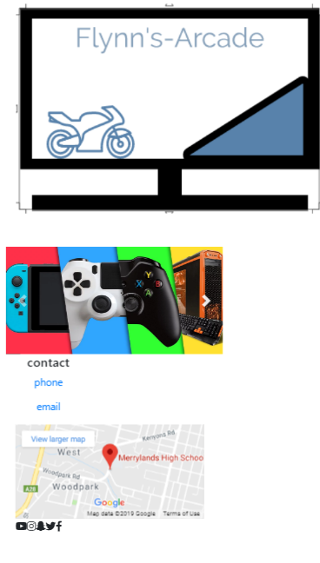

On The Phone Will Look Like Dis

***Notepad++***

Now I will Be Tell You about Notepad Dis Was the Hard One You Had to put too Much with Notepad I Had to Put Lots of Words So I Can Make the Website layout. The Game Is Name is Tron-Legacy in the Movie They Have Motorbikes That Are Neo but Only 3 Colours Blue- Orange and White. Note Pad Makes It Fun to Make Websites the Stuff I Use in note Pad So the Website Come the Way I Won’t It to Come Out. I want The Website to Look Clean In many ways The Best Way I Can Make It

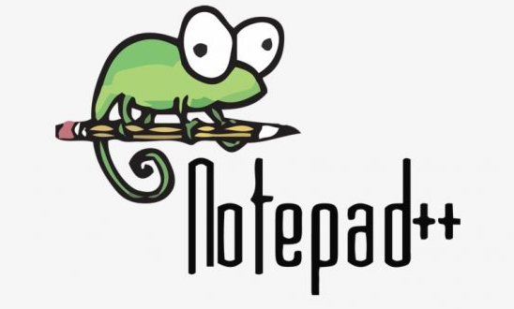

***GitHub***

Now I Used GitHub I Had to Send all My Work to GitHub So All the Photos and Writing Went There Show It Show How To Do It Step By Step . GitHub Is to See Other People Projects and Your Own Work Every Thing You Do You Have to Commit and push Every Thing. GitHub Is Easy To Use Because Every One Get There Own

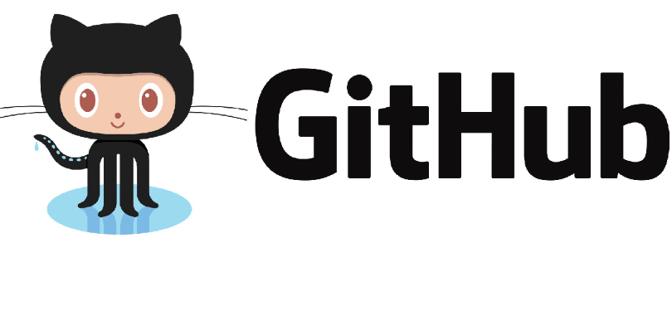

***Bootstrap***

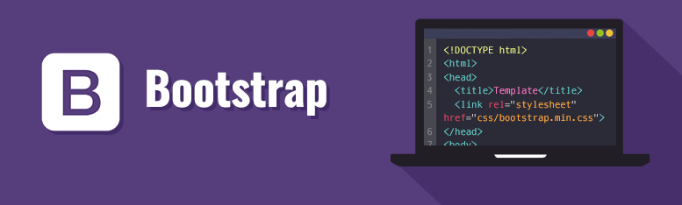

This Is How I Made Sliders and I Got The Links For My Website. I Did the Work And Dis Did the Rest. Boot Strap Made It Easy For Me

***Fandom Website***



Is A Website Where You Can Learn Stuff about Flynn’s Arcade It’s a Multi-Story establishment with numerous and It a Tron Wiki about Every Thing They Do

***Home Network***

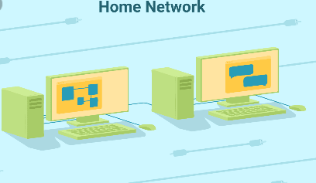

When a Pc Send A Message To A Other Computer From Wi-Fi And Has Mutule Servers To Host The server So The Server 1 Is go And then Server 2 So the Data Goose To A Other PC So The Data Stays There And It Like Home Network And Wi-Fi And You Send People The Stuff You Wont And They Wont

***EB Games*** Help US Ander Stand At The Most Part We Did Research on how the work should be. The Work Should Be High standers If Not People Will Think It’s A Scam



And ***JB Hi-Fi*** Help and Support Page. What We Should Do

